BAck to the

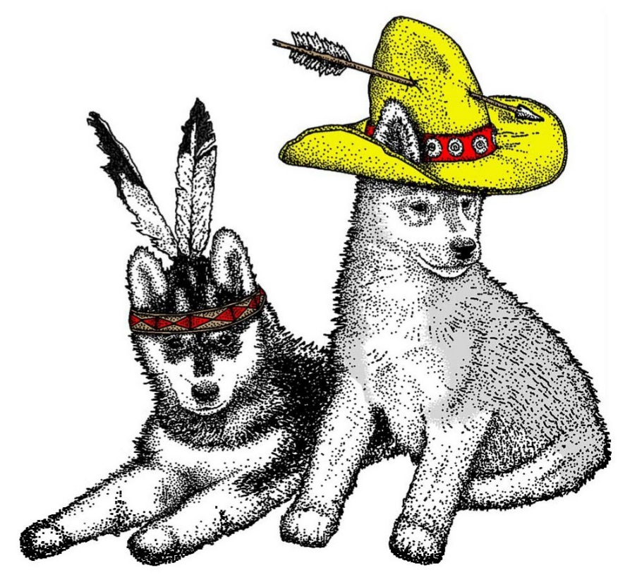 Wild Wild West…